<http://192.168.3.149:1080/haproxyadmin?stats#mysql_server/mysql1>

/etc/keepalived

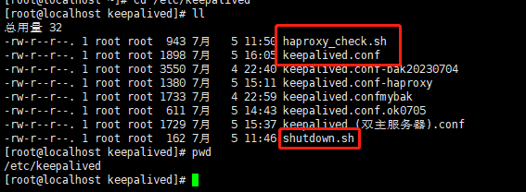

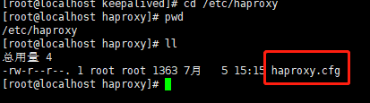

mysql> start slave

mysql -uslavebakuser -p1qaz@WSX -P3307 -h192.168.3.149 -e "show variables like 'server_id'";

